# **Project Documentation: Quasar Books — MERN Stack Online Book Store**

## **1. Introduction**

**Project Title:** Quasar Books  
 **Team Members: SWTID1744137899**

* Anvesha Rathore
* Diya Mittal
* Shreya Sahu
* Suhani Singh

## **2. Project Overview**

### **Purpose**

Quasar Books is an online bookstore providing users with a seamless platform to browse, buy, and manage books. Admins can manage inventory, users, and orders efficiently.  
You can sign up, log in, and browse books by genre, author, or popularity. When you find something you like, just add it to your cart and place the order. You’ll get a confirmation, and you can always check your order history later.There’s also an admin panel where books can be added or updated, inventory is managed, and orders are tracked in real time.

### **Key Features**

* **User Roles**
  + *Users:* Browse, add to cart/favorites, place orders
  + *Admins:* Add/edit/delete books, manage users and orders
* **Authentication:** Secure login/signup with JWT
* **Dynamic UI:** Real-time cart and favorites updates
* **Responsive Design:** Optimized for all devices

## **3. Architecture**

### **Frontend (React)**

* **Framework:** React with Vite
* **State Management:** Redux Toolkit
* **Styling:** Tailwind CSS
* **Routing:** React Router
* **API Integration:** Axios

### **Backend (Node.js + Express)**

* **Framework:** Express.js
* **Authentication:** JWT + Bcrypt
* **Routing:** RESTful API for users, books, and orders

### **Database (MongoDB)**

* **Collections:**
  + *Users:* Credentials, roles, cart, favorites
  + *Books:* Title, author, price, genre, image, etc
  + *Orders:* Book IDs, user ID, total, status

## 

## 

## 

## 

## **4. Setup Instructions**

#### **Prerequisites**

* Node.js v16+
* MongoDB Atlas or local instance
* Git

#### **Installation**

#### **Clone the Repo**

git clone [your-repo-url]

cd bo

#### 

#### **Backend Setup**

cd backend

npm install

cp .env.example .env # Add MONGO_URI, JWT_SECRET

npm start



#### **Frontend Setup**

cd ../frontend

npm install

npm run dev



## 

## **5. Folder Structure**

#### **Frontend**

src/

├── assets/ # Static assets (images, etc.)

├── components/ # UI Components

├── pages/ # Route pages

├── store/ # Redux slices

├── App.css # Global styles

├── App.jsx # App Router

├── index.css # Tailwind base styles

├── main.jsx # Entry Point

#### **Backend**

backend/

├── conn/ # DB Connection Logic

│ └── conn.js

├── models/ # Mongoose Schemas (User, Book, Order)

│ ├── book.js

│ ├── order.js

│ └── user.js

├── routes/ # Express Routes

│ ├── book.js

│ ├── cart.js

│ ├── favourite.js

│ ├── order.js

│ ├── user.js

│ └── userAuth.js

├── app.js # Server Setup

├── .env # Environment Config

└── package.json # Backend Dependencies

## **6. Running the Application**

* **Frontend:** npm run dev (Runs on<http://localhost:5173>)
* **Backend:** npm start (Runs on<http://localhost:1000>)

## **7. API Documentation**

## **Base URL**

****http://localhost:<PORT>/api/v1

## **Endpoint Summary Table**

| **Category** | **Method** | **Endpoint** | **Description** |
| --- | --- | --- | --- |
| Auth | POST | /sign-up | Create a new user |
| Auth | POST | /sign-in | User login and JWT retrieval |
| User | GET | /get-user-information | Get user info |
| User | PUT | /update-address | Update user address |
| Books | POST | /add-book | Add book (Admin) |
| Books | PUT | /update-book/:id | Update book (Admin) |
| Books | DELETE | /delete-book/:id | Delete book (Admin) |
| Books | GET | /get-book | Get all books |
| Books | GET | /get-recent-books | Get recently added books |
| Books | GET | /get-book-by-id/:id | Get book by ID |
| Cart | PUT | /add-to-cart | Add book to cart |
| Cart | PUT | /remove-from-cart/:bookid | Remove book from cart |
| Cart | GET | /get-user-cart | Get user's cart |
| Favourites | PUT | /add-book-to-favourite | Add book to favourites |
| Favourites | PUT | /remove-book-from-favourite | Remove book from favourites |
| Favourites | GET | /get-favourite-books | Get user's favourite books |
| Orders | POST | /place-order | Place a new order |
| Orders | GET | /get-order-history | Get user's order history |
| Orders (Admin) | GET | /get-all-orders | Get all orders (Admin) |
| Orders (Admin) | PUT | /update-order-status/:id | Update order status (Admin) |

Full API docs available in api.md

## **8. Authentication**

* JWT tokens issued on login (valid for 1hour)
* Protected routes via middleware
* Role-based access control (RBAC) for admin routes

## **9. User Interface**

* **Homepage:** Browse books  
  





* **Book Details Page**





* **Book cart, favorites and order history:**  orders for user

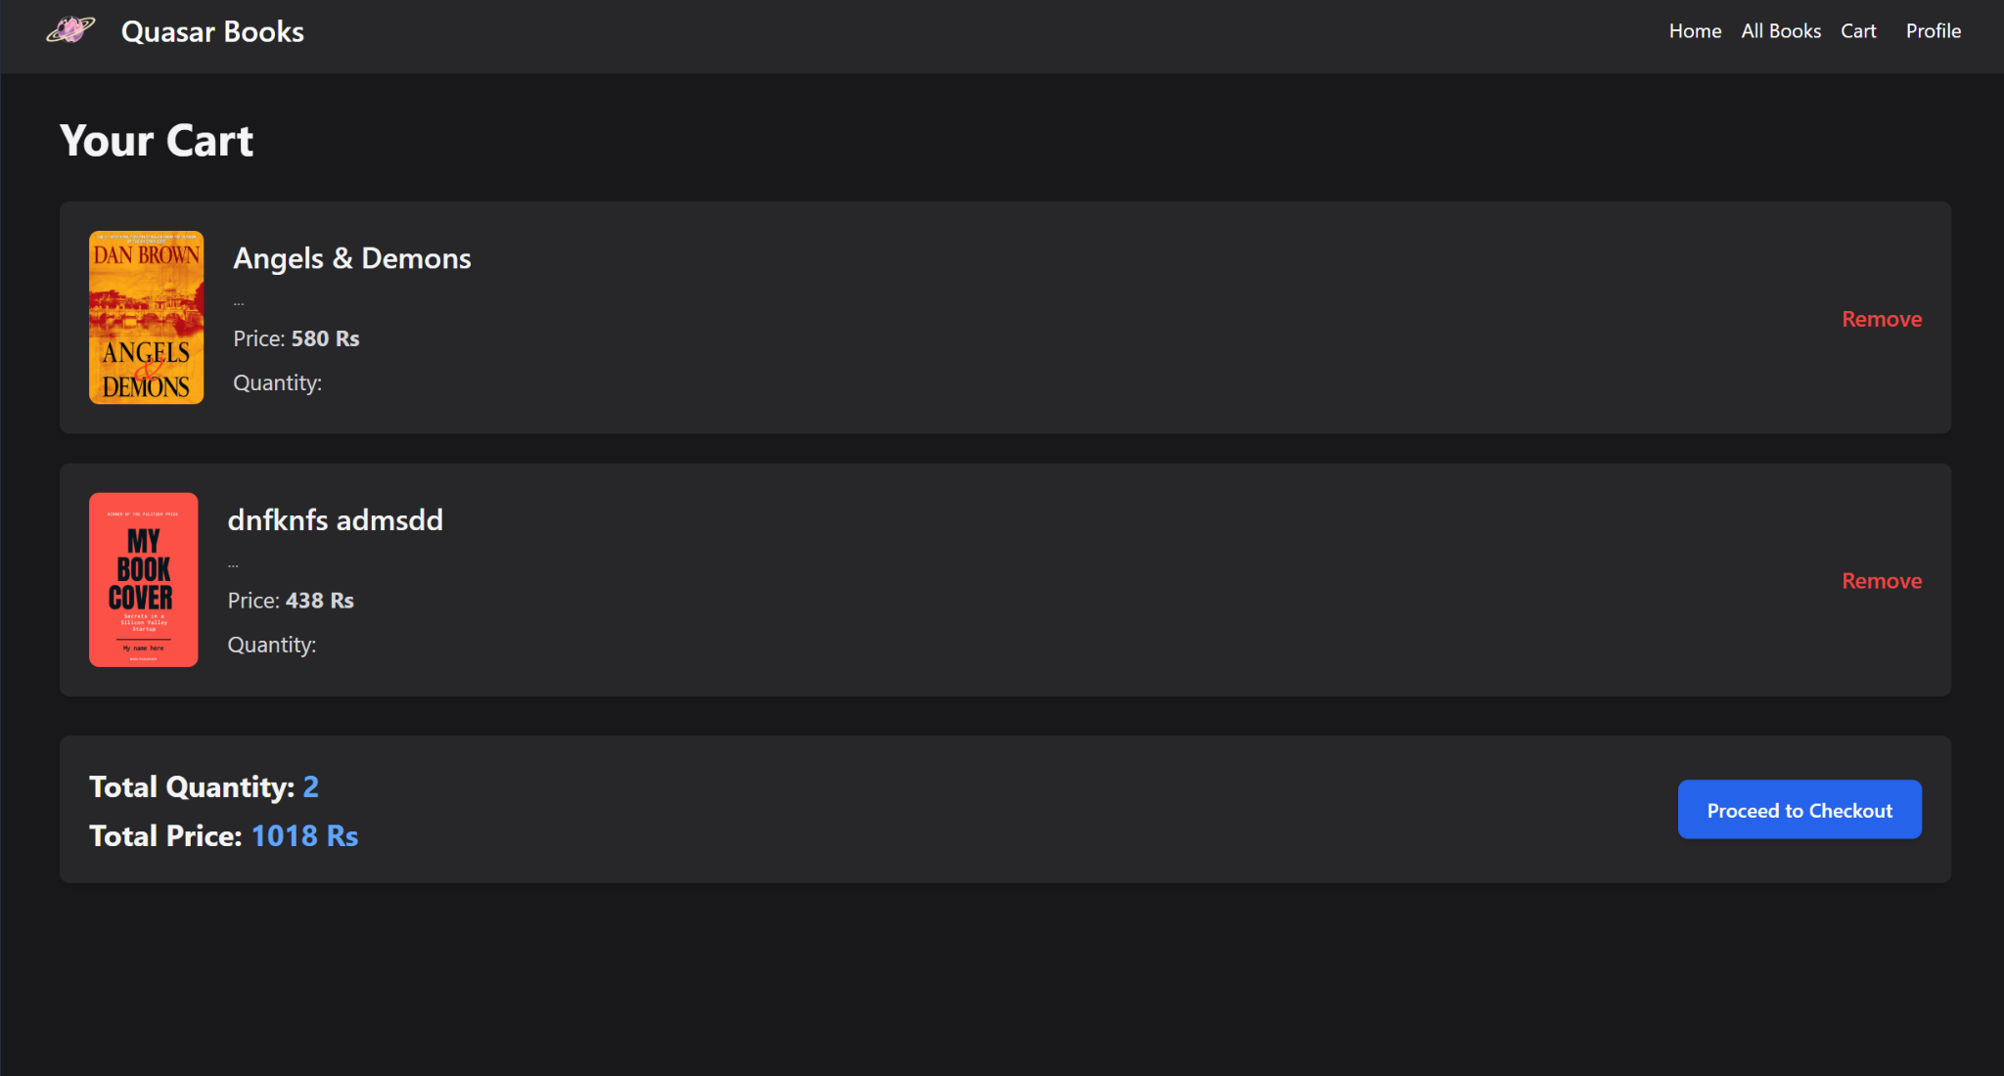

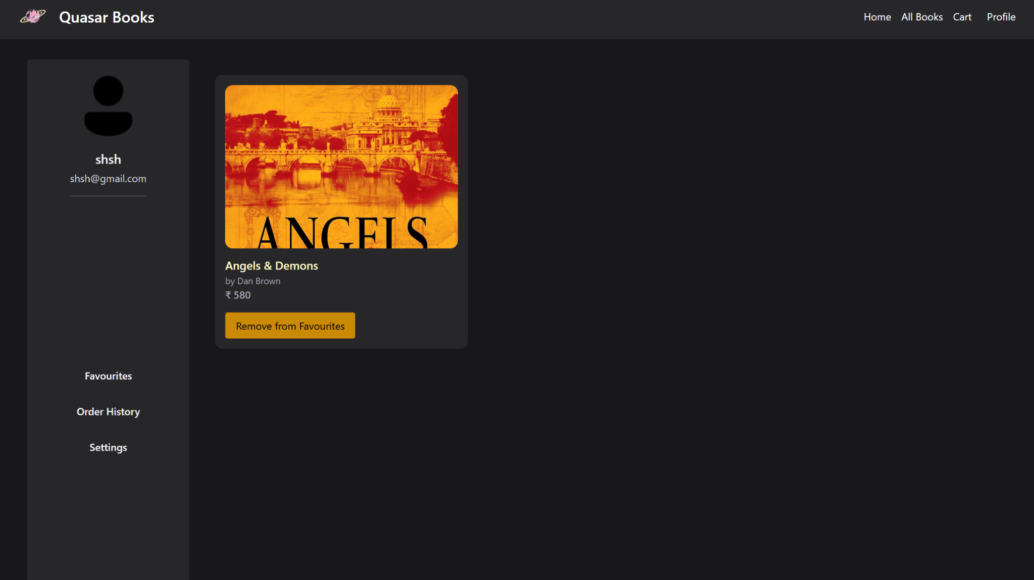

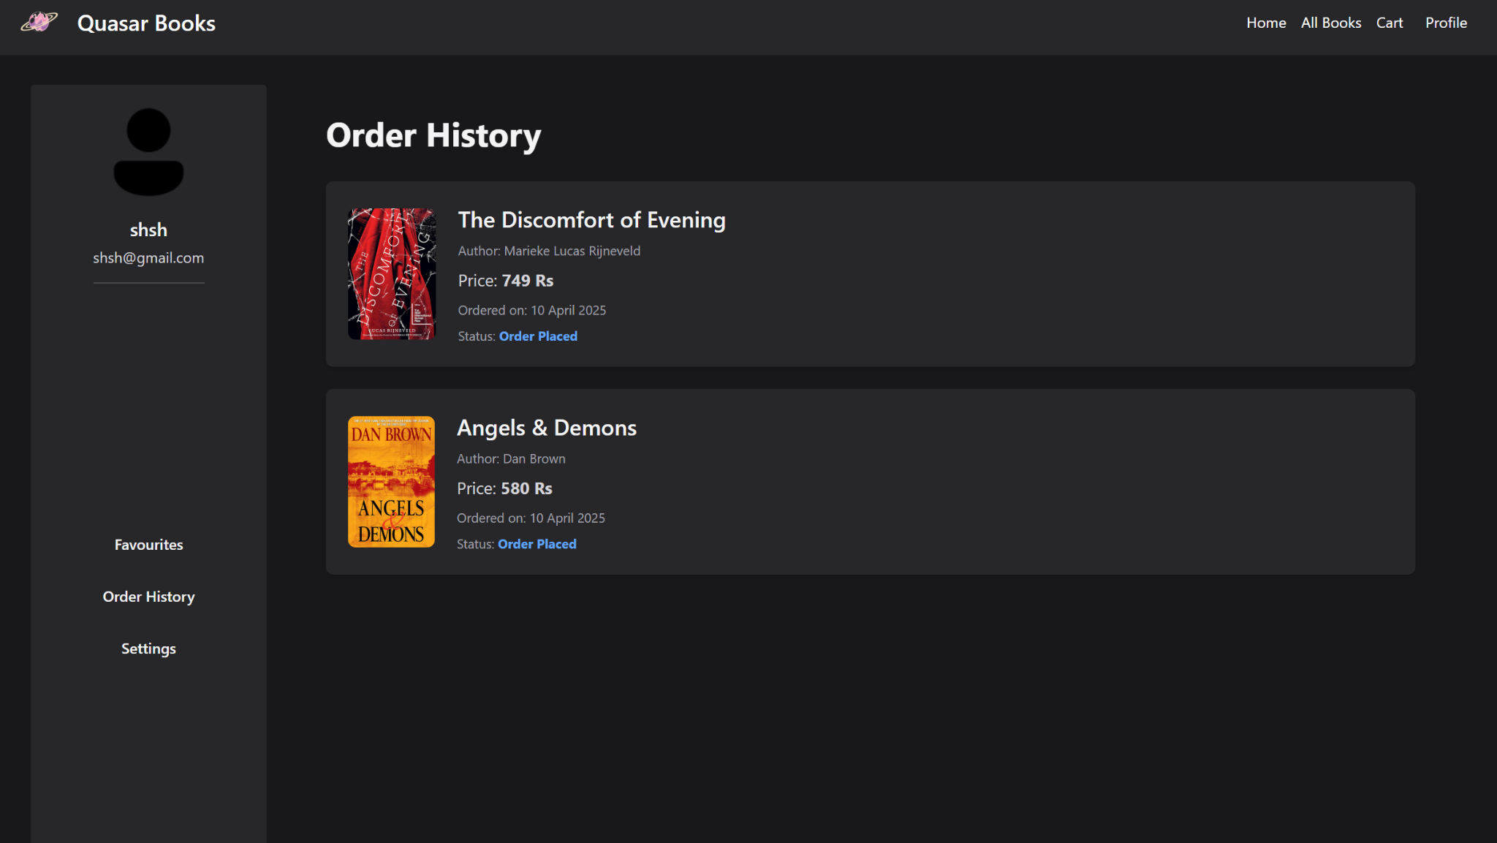

* **Admin Panel:** Inventory & Order Management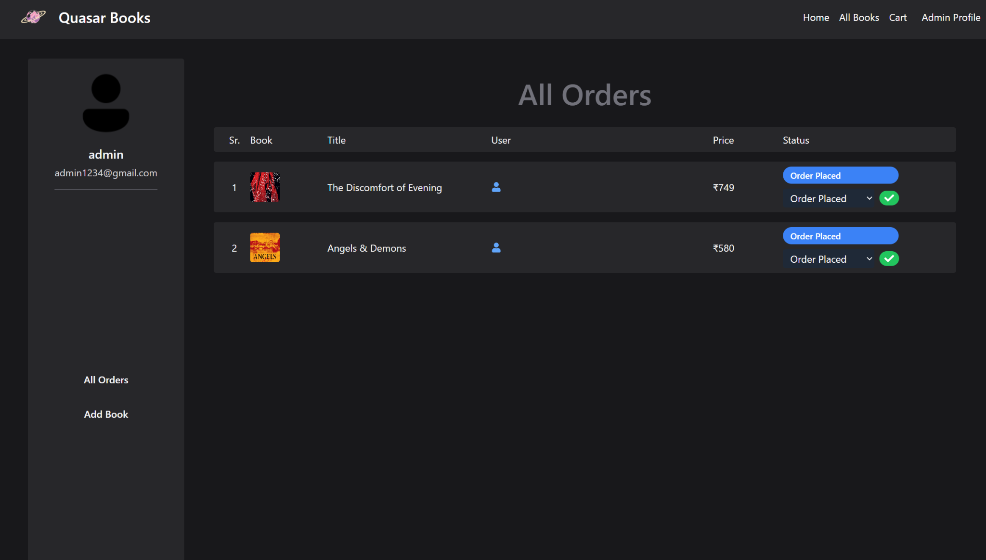

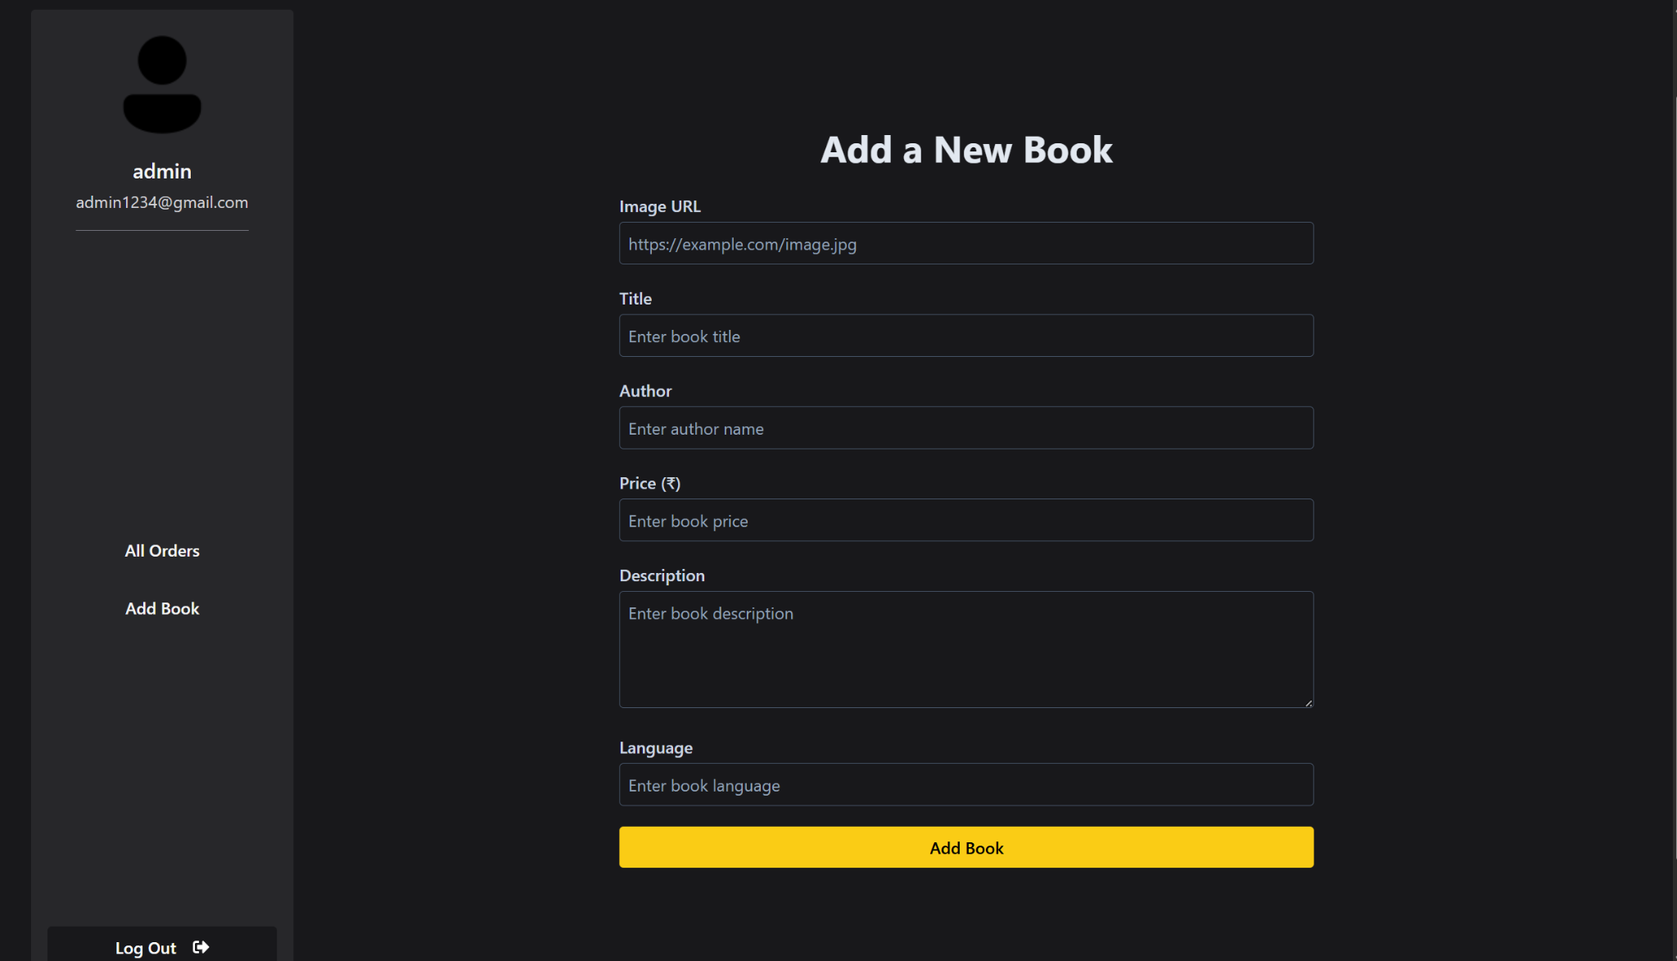

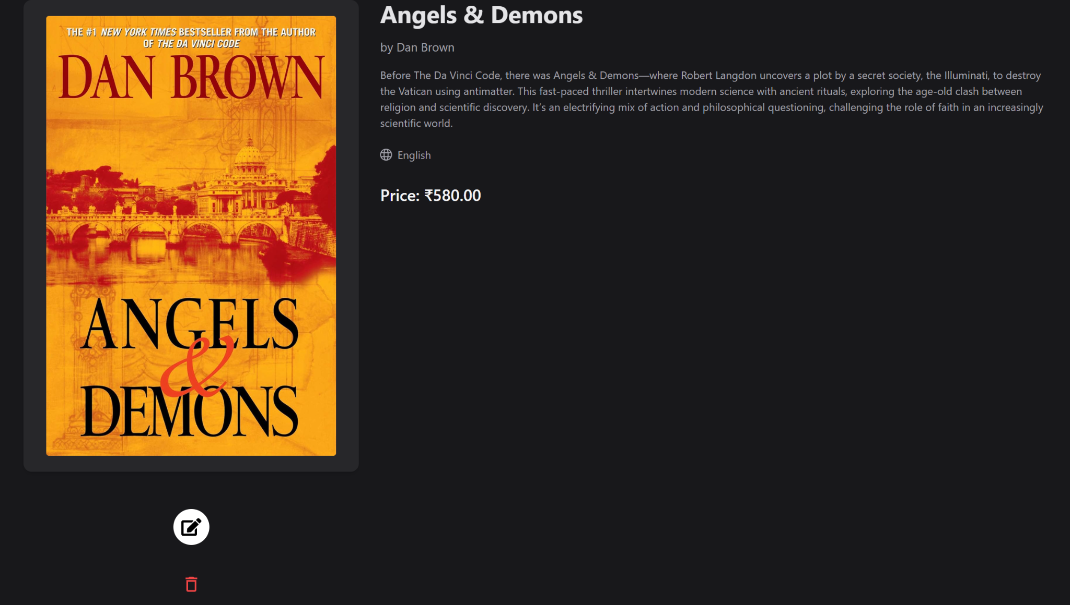

## **10. Testing**

* Manual testing for user/admin flows
* API tested with Postman
* Planned: Jest + React Testing Library for frontend

## **11. Known Issues**

* Cart occasionally desyncs with rapid actions
* Minor responsive glitches on very small screens

## **12. Future Enhancements**

* Add search and filtering (title, author)
* Integrate Stripe/PayPal for payments
* Add ratings, reviews, and user profiles

## **13. Deployment**

* **Frontend:** Netlify
* **Backend:** Render
* **GitHub:**<https://github.com/shreying/QMERN-store>
* **Live Demo:**